Business Intelligence Center
Maintenance Operations
CDOS-Xentity 2014-2025
Overview and Introduction 1
BIC Dataset Tracker 2
PublishedData 2
DataLeads 2
CIMAllData 2
Field Descriptions 2
General Rules for cleaning up Field Descriptions 3
ViewMetadata 3
Other Tabs 3
UpdateCounts 3
Taxonomy 4
The Colorado Information Marketplace 4
Basic Usage 4
API 5
Administration 6
Files temporarily under maintenance/ not updating 7
‘Catalog’, ‘Asset Inventory’, and dataset metrics 7
Web Statistics 7
Updating Metadata to CIM 7
Data Metrics 7
Maintenance and Publishing 8
Maintenance and Publishing Complexity 8
Maintenance LOE Calculator 9
Quality vs Quantity 9
SEO and USE 10
What are SEO and USE 10
What matters most in search discovery in a “Google Search” 10
The Data Management Process 11
bic_etl GitHub Repository 11
Setup 11
Best Practices 11
Code Layout 11
ETL Process 12
New Dataset Setup 14
Maintenance Server 14
UpdateCounts 14
Process Overview 14
Error Handling/Maintenance Updates 15
Maintenance Server FTP and CDOS SFTP 16
Maintenance Server Push or Pull Related to Password Reset 17
Socrata Password Reset Process 17
Protocols for Adding a New Agency Server to Server Connection 17
Manual Dataset ETLs Context 17
Update Cycles 17
Changes and Future Features 18
Versioning Data 19
Maintenance Changes 19
Protocols for Adding a Field to a Dataset 19
Protocols for Updating a CIM Dataset to become Static 19
Publishing and Maintenance Process 20
Update Process 22
Quality Assurance 22
QA Prep 22
Environment Setup 23
GitHub Repository 23
Server Access 24
Data Tools 25
External Trasfer Servers
CDOS SFTP
MOVEIT
Socrata Automated Processes
ESRI Servers

Acronyms 26

Overview and Introduction
This Maintenance Operations document is meant to provide an overview of and procedures for how to manage/maintain Business Intelligence Center (BIC) data on the Colorado Information Marketplace. Maintenance is governed by 3 major components, and several sub-components:
- The Datset Tracker
- The Colorado Information Marketplace
- Data Management Infrastructure
  - bic_etl GitHub repository
  - Maintenance Server
  - Manual/Automated dataset ETLs

These components dictate the bulk of the work to manage the update of datasets from state and federal agencies to a public portal to provide a healthy public data climate in the state of Colorado.
An environment setup guide is also included for the tools that will be necessary to manage these components.

BIC Dataset Tracker
A wealth of information on BIC datasets and their maintenance is housed in the BIC Dataset Tracker spreadsheet.
The purpose of this tracker is to reference the state of the program in terms of metadata, and answer the (out of date).

PublishedData
- This tab contains all datasets that have been published to CIM, and all relevant metadata
- 4x4 unique identifiers, under the ‘Socrata Link’ column, connect datasets to the Colorado Information Marketplace (CIM) and other sheets within the workbook
- Everything is hand entered (unless column is gray, in which case it is a formula)
- Serves as the ground truth for available BIC datasets and most dataset metadata on CIM.
- Full documentation detail on GitHub (needs updating)

This no longer exists in the Dataset Tracker!

CIMAllData

As stated above, this has been replaced by a suite of checks that are run daily, but may be changed to weekly. These checks are:
- Dataset Tracker vs Cron – checks the update schedule in the tracker against the actual schedule used in the Cron.
- Dataset Tracker vs CIM Data Last Updated field – this is a doozy of a task. The Data Last Updated field on CIM only registers an update if there is an actual change in the data itself (i.e. when data is uploaded to CIM, but no change in the data was made by the source provider, then this is not registered as an update. To account for this, the Activity Log is scanned for recent successful uploads, which registers all uploads, to check if the data was successfully uploaded to CIM.
- Metadata Updated – Checks on CIM when the datasets metadata was last updated. We update the metadata daily,so if any dataset is out of date, we are alerted. Note is is possible for individual datasets metadata update to fail.
- Published Data tab vs CIM BIC datasets – analyzes if all datasets in this tab are actually on CIM. Note that in 2025, much work went into reconciling differences b/w datasets in the tracker and actually on CIM.
- CIM datasets vs Published Data tab – analyzes if any BIC datasets on CIM are
not found in tracker. See above note.
- Sanity Check – Checks if any BIC datasets on CIM are empty, run daily. Socrata’s Datasync allows empty datafiles to overwrite existing data on CIM. This has happened several times in 2025, so this catches these cases, but only post problem. We are currently (02/2026) building checks into the ETL pipelines to account for this.

Field Descriptions

This tab still exists in the tracker, but is mostly kept for historical purposes, and is not really used. That being said, in 2025, all BIC datasets were evaluated for field description. The results were split into datasets with and without maps. It is common for datasets derived from maps not to contain field descriptions. The datasets without maps were then split into static and dynamic (i.e. updated) datasets, with the dynamic datasets. The dynamic datasets with < 50% of field description coverage are being corrected.

General Rules for cleaning up Field Descriptions
- Ignore all geometry fields in inventory that don't exist in API and add API fields to inventory
- Full Field Name will be in camelCase based off API Field Names according to the BIC standard
  - In situations where API field name is something like “descriptio” the Full Field Name should read description
  - This is the field that will be/should be displayed in the dataset on CIM, and is the field name after any transformations have been applied
- API Field Name will be exactly as listed on CIM API page (example)
- Order is important. Ensure the order of fields is the same as listed on CIM or API Dev site - this allows future QA to be more efficient

ViewMetadata
- This tab contains the metadata about views for a specific dataset. These are views that have been published as a separate dataset.
- As we find views, we document the metadata and link the views to the PublishedData Socrata Link.
- As of Feb, 2026, code needs to be developed to sync these nightly with Socrata overwriting only necessary information, and there is currently a Jira card in the backlog for this.

Other Tabs

UpdateCounts
The current fiscal year cumulative total of the number of datasets that have either been published or are in progress to be published. The data is calculated using the PublishedData Tracker fields - Date Published to CIM and GOCode FY Published to CIM.
To maintain accurate tracking, each Friday, the current week’s counts must be converted from a formula to values.

Taxonomy
This is a working table of category and type taxonomy. All categories on the Colorado Information Marketplace and in the Data Inventory and Metadata workbook need to be reconciled. This tab can be used for future work on taxonomy and defining/creating standards for categorization. Taxonomy categories are used to populate the Category and Type fields in the metadata ( PublishedData tab of the dataset tracker). See current research on Ontologies, Provenance, and Semantic Interoperability (if you dare).

The Colorado Information Marketplace
The Colorado Information Marketplace, or “CIM” is the state of Colorado’s official open data portal. The portal is currently run on Socrata, of Tyler Technologies.

Basic Usage
Data can be browsed in the data catalog.

On the left side of the catalog are options to filter data:
- Authority
  - Official - displays only datasets that were published by a state data provider
  - Community - displays only datasets that have been created by users that filter or sort datasets
- View Types - Different datasets have different views. The two most useful dataset view are:
  - Datasets - tabular datasets
  - Maps - map visualizations can be created with data that is geospatial in nature. Previously, Socrata allowed datasets to be published as maps, but now the data must be published separately from the map view that can be created from it and maps are treated as visualizations.
  - Charts - data visualizations created for specific datasets.
  - External Datasets - datasets can now be created that simpy point to external datasets, no data is stored on CIM.
  - Files and Documents – datasets that simply link to a document or a file, but no data is available.
  - Filtered Views - views of datasets which have been filtered to display a subset(s). One of BIC’s most popular datasets is the Active Nursing Licenses, which is a view (subset) of the Professional and Occupational Licenses dataset.
  - Stories - allows for a collection of datasets to be gathered and described. This has been used sparingly in BIC, but could be very useful in unifying collections of datasets.
  - Forms - not used as of February, 2026.
  - Calendars – not used as of February, 2026.
- Categories - Datasets are given one category at the time of publish. By selecting a category only datasets in that category are displayed. This relates to the Taxonomy noted above.
- Domains - Other agencies in the state have their own data portals that run on Socrata. These agencies have agreed to federate their data to CIM. This allows CIM users to view the federated data without searching through the other data portals. Currently there are two federated domains:
  - City of Fort Collins
- Tags - All datasets are given tags, or keywords when they are published. These are the search terms that allow users to find data, and find connected data like “census” or “charity registration”

Each dataset is given a unique 4 character x 4 character identifier. This is referred to as the dataset 4x4 or the UID. Dataset UIDs are found in the URL of the dataset. For example, the highlighted portion of this URL is the UID: https://data.colorado.gov/Transportation/Highway-Mileposts-in-Colorado/trm9-dm4m

If the UID to a dataset is known, one can quickly navigate to that dataset by replacing the UID of the dataset currently being viewed in the URL. For example, we can take the above url and add a different 4x4 to it, we will be redirected to the new UID dataset primer page.
https://data.colorado.gov/Transportation/Highway-Mileposts-in-Colorado/4ykn-tg5h

The dataset 4x4 is also necessary to utilize Socrata’s API and Metadata API.

API
Socrata has an API for datasets. When on a dataset primer page (like https://data.colorado.gov/Building-and-Facilities/Residence-Characteristics-in-Clear-Creek-County-20/mev7-qffb/about_data), click Actions drop down and then API to get the API endpoint. Clicking on “API Documentation” will bring you to a Socrata page with API examples for the dataset in question.

In 2025, Socrata introduce a new API protoco, SODA3, which requires authentication, for accessing data via API. As of February, 2026, the older SODA 2 , which does not authentication, is still available.

There is a standard limit of 1,000 records when accessing data via the API. This can be over-ridden using the $limit=nnnnn to extract the entire dataset, where nnnnn is some integer larger than the total rerords in the dataset. Note that the limit over-ride is also subject to server side restrictions (i.e. it does not work when using the API from some ESRI servers).

Administration
In 2025, the old oit_datacoloradogov@state.co.us was retired, and we we re provided a new account, bic-help@xentity.com. When logged in to CIM using this new account, we no longer have admin privelages, but slightly lower ???????? account. l,. This allows for updating metadata, updating data and general administration. Click the menu icon in the top left corner and select Administration to go to https://data.colorado.gov/admin. The old datacoloradogov@state.co.us accounts name on CIM was Colorado Information Marketplace, which was the names used for ownership of the BIC datasets. This has been changed to Business Intelligence Center of CO,

Another change is that the Contact Point for all BIC datasets now points to bic-help@xentity.com. This has created an increase in assistance requests from users, but has also provided a more direct method for users to request assistance with BIC datasets.

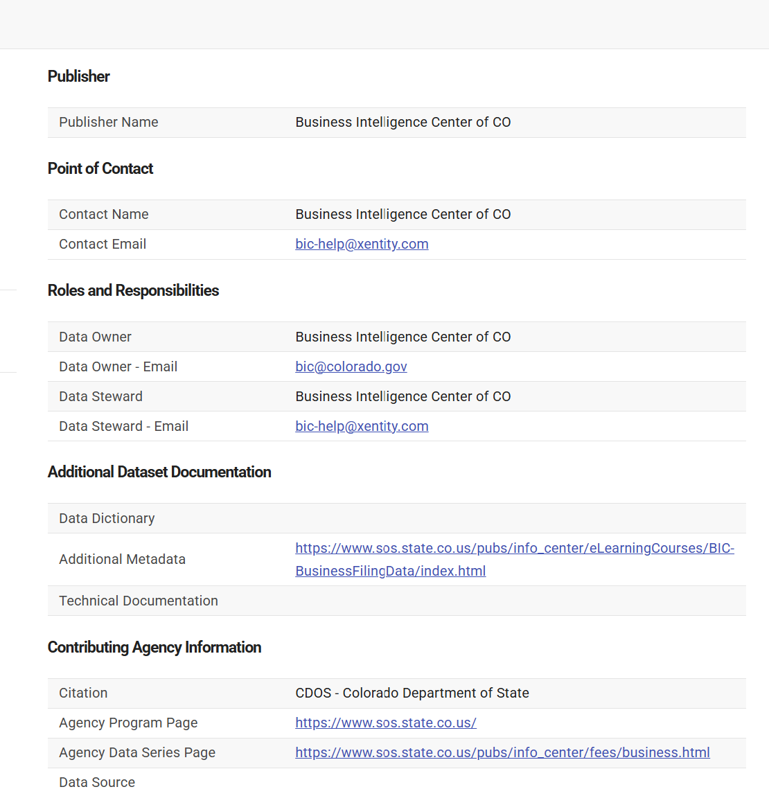

CIM users can still send email to the OIT CIM administrator, Tim Andrews, who forwards BIC related questions to bic-help@xentity.com. Users also occasionally send email directly to the Secretary of State, where the SOS BIC manager, Mariah Jordan, usually forwards the email to bic-help@xentity.com

The State Chief Data Officer sets the direction and manages the CIM portal. The current officer has encouraged some state agencies to publish data on to CIM. BIC is not the only source of official datasets on CIM. BIC and Xentity are not contractually obligated to maintain and curate datasets published directly by other state entities.

Some scenarios require logging in to CIM to implement proper data maintenance procedures. See below for an example.

Files temporarily under maintenance/ not updating

‘Catalog’, ‘Asset Inventory’, and dataset metrics

Web Statistics
Web Statistics are no longer tracked on Socrata. The OIT organization owns the CIM website. Web Statistics are under their ownership at this time. However, as part of the dataset metadata available via the Socrata Maintenance API, total page views and dataset downloads, and also for the most recent month. Socrata also provides a dataset that contains detailed usage on downloads, api hits and views via hourly counts which we sometimes use to compute the 100 top BIC dataset per usage score.

Updating Metadata to CIM
We utilize the Socrata Metadata API to bulk edit metadata on CIM.
The metadata updater script can be found in bic_etl on GitHub under general/metadata_updater. Documentation can be found in the readme on github. The script is written in Python 3 and is currently scheduled to run nightly in the cron file.
When publishing or doing quick manual edits, you may simply input the metadata in the internal metadata repository and on Socrata via the edit button on the dataset page.

Publishing
As of fiscal year 2026, publishing is no longer part of the SOS contract. Please reference the publishing in the previous Data Maintenance Document.

SEO and USE

The Data Management Process

bic_etl GitHub Repository
This contains the information about the bic_etl GitHub repository. This repository is used to maintain data on https://data.colorado.gov for specific datasets. BIC stands for the Business Intelligence Center, and ETL stands for Extract, Transform, and Load.

Setup
The repository is on GitHub under the GoCode organization. It is a private repository, access needs to be granted by a current user or admin. Use GitHub documentation for a guide on how to clone, push, pull, and other usage. You may find that GitHub client is simpler to use than the command line. The repo can also be accessed via the Visual Studio Code editor. See here for more info.

Best Practices
A number of best practices for technical processes are to be documented on our GitHub documentation, including GitHub branching, data management, and password management/sharing.

Code Layout
The system is organized by department (like cdos, the Colorado Department of State), as the data processes are often in similar patterns for each department. Only the departments that have an ETL process (manual or automated) exist in this system.
There are also several other folders for various things
- general - contains all the relevant logs, cron files, examples, and general scripts used by various departments
- qa - contains scripts and documentation on quality assurance processes ????
- documentation - contains various documentation concepts that relate to the system as a whole and not a specific organization. ????
Example Suite
In the general folder, there is a folder labeled example. Each dataset suite contains a similar folder structure: data_compare, data_source, data_transformed,scripts and occasionally defs . It also contains a readme.md file, and a run_etl.json file. The readme.md file contains various information that may be relevant to the data suite. The run_etl.json file contains the information needed to run a data suite. Blank readme.md files are included in various folders to assure the correct folder structure is created and maintained on GitHub (which only tracks files, and not folders).

Passwords
A variety of passwords are utilized across the system for data download and data upload, as well as the email system. These passwords are not anywhere in the code, but are stored in environment or system variables. The implementation depends upon the OS and environment.
All passwords should be stored as a system variable, and accessed accordingly (not on GitHub!). To setup or manage passwords, use our guide on GitHub. Passwords are distributed on an as-needed basis, contact the BIC maintenance admin for the most recent passwords.

All passwords and api keys are now managed using a centralized password management system.

run_etl.json
For each suite, at the root there is a run_etl.json file. This file contains the necessary information for each dataset in the suite on the ETL process. More detailed documentation can be found on GitHub.

Cron system
This manages what gets run when on the maintenance production server and is only utilized there. A simple cp (copy) command is used to transfer the cron file to the correct place for implementation. See our documentation for specific details.

Logging
The technical specs of the logging are detailed here. The logs are sent out daily to the data managers for any errors, triage that needs to be done, etc.

ETL Process
The ETL processes are a standard architecture format for handling data flows. The below details our processes for the datasets at a high level for each piece, and how the suites of ETL’s are run.

Introduction to ETL
ETL stands for Extract, Transform and Load, is an industry standard architecture for the field of Data Science. The goal is to get all datasets set up with automated maintenance. The more automated the process, the better it is for the quality of the data and the experience for the end users. Some datasets cannot be automated due to requirements or limitations of the source environments that the data is being extracted from.
It is important to note that there will always be two manual requirements for the program
- New Datasets
  - Every time a new dataset is created, it is a manual process to create the new dataset, get the dataset 4x4 (id) and enter the metadata from the metadata template completed by the Subject Matter Expert (SME)
- Testing Environment
  - A local environment of all the script files and necessary code libraries is maintained on each technician’s computer (linked via GitHub). Variables and data formats will sometimes change from the source providers that will require script modifications. These scripts will be tested and fixed in a local environment, and then the server script will be updated to handle the modifications in future data updates.

A very general overview of the process as provided to potential data publishers.

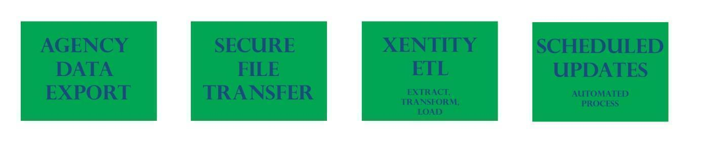
Extract
- Can be either a push (from the agency) or a pull (the BIC ETL system grabbing the data)
- In some scenarios, Xentity will consider other options for data transfer, but these two are ideal for automation.
- Socrata provides several options for performing this step on CIM, both via http extract methods and via an ESRI server pull. These methods are utilized for mutliple datasets, but is only available for datasets that do not require transformations.

Transform
- Scripting languages installed on the server - Node or Python 3
  - In recent years, we have been converting many Node scripts to Python, with the goal for all scripts, generalized and dataset specific, to be Python. There is no timetable for this, just a long term goal.
- Most often this step will occur in the Maintenance Server environment that has been established by Xentity in the State’s OIT environment
- For most examples, Xentity designs a series of Python actions that ensure the standardization of the data format.
- Not always required, depending on agency’s data
Load
- This is the step of moving the transformed dataset from the Maintenance Server to the CIM.
- The first time a dataset is loaded/created on CIM it is a manual process because the dataset has to be built in the online environment – meaning the dataset format is set, . Metadata is entered in the PublishedData tab in the dataset tracker.
  - See Publishing Operations for more detailed information
- DataSync, a Java based program maintained by Socrata, can either be used through the GUI or the command line
- DataSync is on version 1.9.9, however, version 1.9.8 and 1.9.9 have shown to be slighly unstable as they do not stored the needed passwords correctly, so we are currently using version 1.9.1. Tyler is aware of the issue, however, they have indicated datasync is an older load utility and it would be beneficial to use the Socrta Python API for transfers. There is a task on the Jira board for this.

Rules/Dictionaries
There are various rule data sets and data dictionaries that are used as part of the transform process. These are utilized on an as-needed basis. These are meant to standardize datasets to given forced limited sets, or transform to known values. As of 2025, we no longer perform any corrections on the CDOS datasets per SOS directives. However, when needed, we are using field name dictionaries to insure field name consistency and camel-case conversion, when needed. Many of the CDOS datasets use this method, as do some other datasets. These dictionaries provide source name, camel case conversions and field definitions.

Load Scripts
Load scripts use Datasync, a Java application, to create Socrata Integration Jobs (.sij files), to upload .csv and .tsv files to CIM. Our step by step process is documented here.
- .sij files are formatted identically to JSON
- There is a .sij file for each automated load to CIM
- Each .sij file maps a field in the table to a field created on CIM and matches the formatting. Note it is possible to perform field name conversions to camel case via the sij file, and on CIM, however the preferred method is to use transform scripts as it provides better provenance and tracking.

New Dataset Setup
Datasets are added to the maintenance system every year. Automation is always preferred for new datasets, where practical.

Virtualization of Code
The code needs to be siloed and virtualized so that library dependency does not cause slow downs in delivery. Documentation on the process for both Node and Python can be found on GitHub.

Protocols for Adding New Datasets
The step by step process for setting up a new automation process is documented here. The general concepts are to maintain code integrity, follow protocols for review, test pieces of architecture individually and together, and simple rollout to production once ready.

Maintenance Server

In 2025, OIT provided a new server, at 10.12.1.18. This has now been fully vetted and all maintenance processes are running on this server.

UpdateCounts
The BIC Dataset Tracker contains the Update Counts and data maintenance framework (via UpdateCounts tab,) and updates as changes are made to the framework on a day to day basis.

Process Overview
The system requires several moving parts and scripts to have a CI/CD (continuous integration continuous development) framework, as well as scripts that run other scripts and external (extract & load) scripts and programs. This section is focused on all these things, and the next section focuses on specific ETL implementation.

As of June 2024, the Secretary of State’s office has mandated that non-Secretary of State Agency data be removed from the CDOS SFTP server.Agencies have now been transferred to the OIT MOVEIT server. Xentity employees working on BIC also have accounts on MOVEIT. .

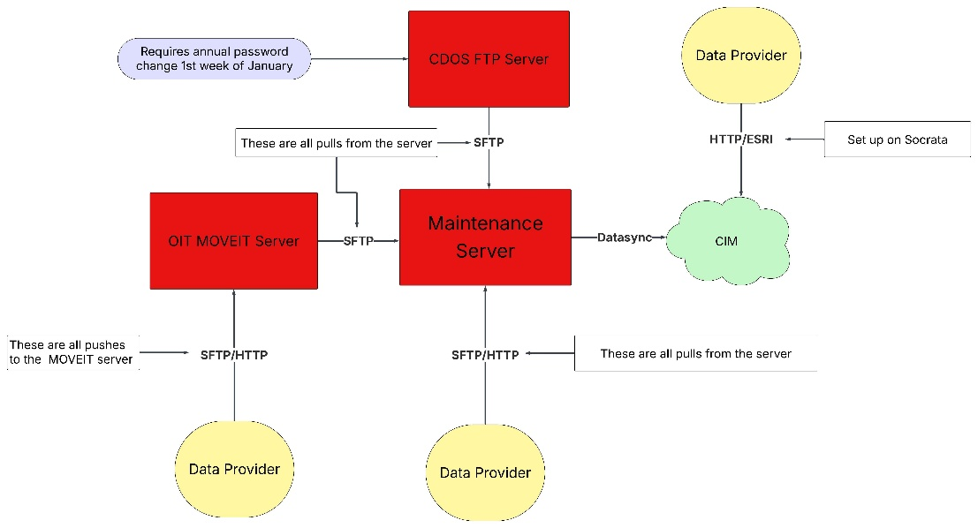

Server Architecture
Most of the server code is isolated at /usr/local/cim/bic_etl. The folder at /usr/local/cim is an isolated drive with 200G of space. The /home directory has 25G of space. The account used to control all ETL process is giddensm and the home directory is /home/giddensm.

Error Handling/Maintenance Updates
Changes to a script
When changes to a process are required, they should be able to be locally tested, updated, and pushed to GitHub via a branch and approved to production by a team member via a Pull Request (PR). GitHub’s production branch is pulled nightly before any jobs are run, so any changes made during business hours will be implemented that night for any ETL processes. Note one difference between this new server and the old server is that the main repo is updating nightly at /user/local/cim/bic_etl, when transferring all services to this new server, the repo was also cloned under /home/giddensm/bic_etl, for branch work. This has occasionally caused issues as the environment variable bic_etl_home has to be set to the correct location of which repo you are working in. It likely is time to remove the /home/giddensm/bic_etl clone!

Email Notifications
The email system is designed to take a daily log file and give a general overview of what occurred: errors, total logs, etc. It runs daily at 10am. It is sent to bic-help@xentity.com, which is a google group that then forwards to the team. All logic is in the general/scripts/cleanup.js file. If an issue is in the email that is not expected, follow the error triage instructions below.

Error Triage
The error handling process is detailed on GitHub, with examples.

Force run all dataset

Documenting Fixes

The Change Log has been replaced with the BIC Jira board. Fixes and changes are entered as stories in Jira. Each dataset group (denver,boulder,cdos/business/business,…) has a readme.md and a changelog.md file where changes should be logged. We have been using these interchangeably unfortunately and in the future, need to consolidate how we do this.

Maintenance Server FTP and CDOS SFTP
CDOS SFTP
As of June 2024, the Secretary of State’s office restricts the CDOS SFTP server exclusively to CDOS datasets. All other data transfers have been migrated to alternative platforms, such as the OIT MOVEit server. Because access to the CDOS FTP server is restricted via an allowlist, any new IP addresses must be approved by Joe Bianchi (Joe.Bianchi@coloradosos.gov). Users accessing the xenbic@ftps.sos.state.co.us account from local machines should note that dynamic IP changes will require updated allowlist requests. The password for the xenbic account needs to be changed the 1st week of January. Any password change process is documented here.

Maintenance Server FTP

Maintenance Server Push or Pull Related to Password Reset

Socrata Password Reset Process
The password to Socrata is the critical component for the load. It does not need to be changed on a schedule, but the process to update it is detailed here.

Manual Dataset ETLs Context
Some datasets require manual updates at regular intervals. Currently these datasets only occur on a semi-annual and annual basis. -> We need a central place for this. There is a Manual Updates tab in the dataset tracker for this, but I am not certain if this maintained.

Update Cycles
The annual manual update cycle typically takes place in January and February. To view the datasets that need to be updated manually on an annual basis, visit the BIC Dataset Tracker and filter on the “Update Type” column in the PublishedData tab. View the “Manual Updates” section to view update histories.

Previous Years efforts
2015 – First year we did maintenance, we used it to clean up metadata and verify all datasets were being updated appropriately using the automated system
QA process checklist. The workflow used in the QA checklist is outlined in this doc Workflow and Errors Fix. The important takeaway is that there are various ways we can use this ‘annual manual’ exercise to beef up our quality control measures. For brainstorming, we considered the idea of producing a unique values list for all datasets with text fields of interest. This is also where the idea of the maintenance log was born, but not fleshed out or built beyond a skeleton.

2016 - Much more mature data maintenance effort was intended, but looks like we didn’t do any QA work this year, and spent the majority of this effort just updating manual datasets. We used the first (and last) version of the Maintenance Scorecard, and also this was the year that the Maintenance Plan was born. This was also the first year for the Socrata Ticket Tracker log.

2017 - Still using the Socrata Ticket Tracker log. We started documentation on metadata change requirements to accompany updates. This one page document requested by the CDO gives an overview of what is required to update each data set.

2018 - Requirements for 2018 maintenance update process
- Place to keep track of details related to each specific agency - Where does the incoming data go? Who sends out emails to whom? What agencies are automated and what are the notes that go along with their setup?
- QA checklist - what QA items do we need to do each year, how do we document it so there is a record of the process? Will need to have a manual to go along with this spreadsheet (likely).
- Temporal record of maintenance? How do we know that we successfully updated these things each year? Can we retroactively fill out columns with initials of who ‘owned’ the update for each year?
- Maintenance log and changelog - how do we keep track of the little things that change year to year? Ie this field header changed, stuff like that.

2019 - Manual Update cycle mostly complete

2020 - Heavy effort made to utilize the Maintenance Trello board to organize manual updates. Efforts made to improve documentation for manual datasets on the bic_etl github.

2024 - Heavy effort made to reduce the errors in automated loads to CIM.

2025 – Moved to new OIT server. Efforts to remove all data cleaning and corrections from the CDOS datasets and convert all Node scripts to Python. Major effort to sync BIC CIM datasets with PublishedData tabs in the Dataset Tracker.

Changes and Future Features
Historically, the Change Log & SME Communication document tracked two processes on two tabs:
- Maintenance Changes - Changes to maintenance operations
- Relevant Communication - Relevant communication from SME

Going forward, changes or future features are tracked via Jira stories and kept in the backlog until implemented.

Versioning Data
Certain datasets have data that is published for a single year, each year a new dataset. These remain public and are utilized to compare year over year statistics. If a datasets model changes and we need to keep the old and new versions, you can link the datasets through CIM and cover the relevant similarities and differences in the metadata.
If a dataset must be removed from the public (not done to this point), an internal archive is created. Download the raw data and bundle the relevant metadata and documentation in a folder, and zip the whole folder and place it in G-drive for the corresponding GoCode year.

In 2026, dataset versioning was made available on Socrata by OIT. As of March 2026, only a select number of BIC’s datasets have versioning turned on.

Protocols for Adding a Field to a Dataset
It is not uncommon for data source to remove or add data fields from datasets, often without any notification. The process for changing fields for a dataset is:
- Update fields and descriptions on CIM
- Update transform script
- Update .sij file either manually or via datasync
- Run full update suite to insure all is well

Protocols for Updating a CIM Dataset to become Static
Occasionally it will be necessary to in a sense deprecate a dataset on CIM that receives occasional updates. For example, a new source for crime data was discovered by the team in 2025. A New dataset was created that was more comprehensive than the existing crime data on CIM. So, we updated the old datasets metadata on CIM to reflect the fact that they will no longer receive updates and point to the new dataset. In short, you must:
- Update short and long descriptions as necessary
- Update the “Update Schedule” metadata field to “Static”
- Update any other update related metadata fields to Static or None depending on the Field
- Update related datasets if necessary to the new dataset location that will have updates/is not static
- Add the date range to the title

Note, dataset metadata should NOT be updated directly on CIM. The Dataset Tracker’s PublishedData tab should be updated. All BIC CIM dataset’s metadata is updated every day using the PublishedData tab as the ground truth! Any metadata changed directly on CIM will be over-written the next day! The only metadata on CIM that should be changed are field names and descriptions. These are NOT updated via any automated processes.

Publishing and Maintenance Process
The most basic description of the file transfer process involves three basic steps:
- Agency extracts data from their database
- Agency provided data via some transfer method, either http or sftp. Most require pulls but there are some data source that push to the OIT MOVEit server or some other external server.
- Xentity scripts on Maintenance Server run on schedule to process data via pull
- Xentity scripts on Maintenance Server run to push transformed data to public portal
Further documentation on publishing can be found in the Data Publishing Overview

Agency Relationships
The very first step in all Publishing workflows begins with a phone call. Well, sometimes with scouring a government website to find a person and a phone number, but ideally through a connection or other network friend who knows the right person to talk to.
Publishing and Maintenance Process Diagram
The diagram of the process used to communicate with providers about the process provides an overview of the original idealized vision of the process wherein each agency will have a direct network connection through the firewall. This is a high level process document and may be out of synch with actual detailed process.
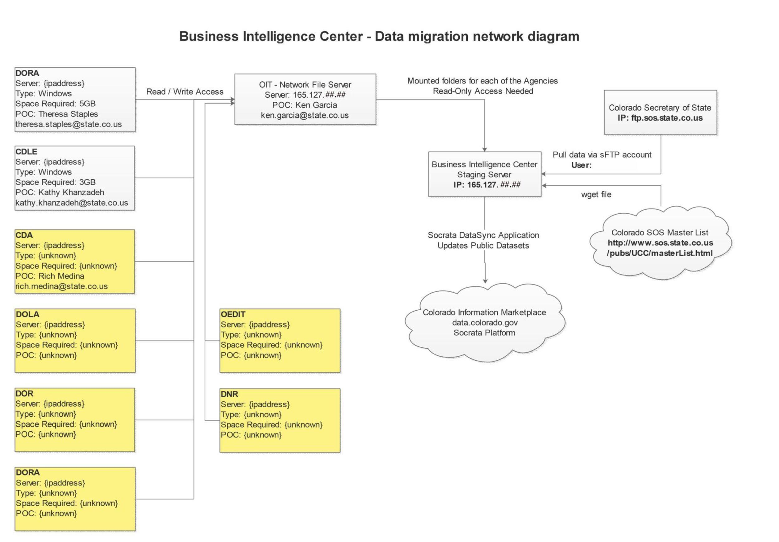

MOVEIT Server
The go OIT’s MOVEIT server is now available for agencies to use for data transfers for BIC. The MOVEIT server’s purpose is a passthrough for state agency data and sharing across agency/department.
SFTP access is setup to automatically process agency files as the datasets are moved to the MOVEIT server.
A web interface is also available that we can use to login and view datasets available to BIC. Kalpana Hanumantharao can work with team members to get Web interface access.

Agency Relationships and Metadata
Xentity has worked with Socrata to configure a batch system for updating metadata and field descriptions. Xentity has designed standards for naming schemas and descriptions that are designed to improve the readability of the CIM catalog. In 2024, OIT, which manages CIM, started an effort to clean and homogenize metadata on CIM and the BIC datasets have adopted these standards.

Quality Assurance

It is important to distinguish between QA and the publishing process.

QA Prep
In the early years of the project, much effort went into checking and improving dataset metadata. At this time, the metadata content and infrastructure are mature and efforts have switched to maintenance and identifying areas for improvement.

Automated checks have been created that check:
- Conformity between the Dataset Tracker PublishedData tab and CIM dataset listings
- Period of last metadata update on CIM
- Agreement between Cron ETL pipeline schedules and PublishedData tab update schedule
- Period since last data update on CIM and PublishedData tab update schedule
- Sanity check for datasets with no records on CIM

These checks run daily and send results of all checks to bic-help@xentity.com.

In 2026 and analysis was performed on field description coverage for all datasets. ---- Datasets had fields with no description, however ---- were maps and it is common for map datasets to not have field descriptions. Of the ----- remaining datasets, ----- were static, so these were saved for a later pass for improvement. At this time, the goal is to add field descriptions to the ---- datasets that have an ETL pipeline. In the future, we will attempt to add field descriptions to the maps.

For CDOS Business and Charity datasets and a few other dataset, we have instituted automated column checking in the transform step. This requires a source-transform dictionary be created that contains the original source column name, the camel case column name on CIM and the field description. An alert is sent via the logging system

.

Environment Setup

GitHub Repository
Overview
The official scripts used to run the Maintenance Server can be found in the GitHub repository: https://github.com/GoCodeColorado/bic_etl (access approval required). This workspace contains all current scripts and is also used to house the historical versions of the scripts, though effort has gone into removing the historical scripts as they are available through GitHub branchs in the repository. It is designed to be a Continuous Integration/Continuous Delivery (CI/CD) system, with easy usage on a local machine and automatic pulls onto the maintenance server for implementation.

In order to use this code, the following tools will need to be set up and understood.

Code Editor
This is almost a complete preference. If you do not have a place to start, consider VS Code (Microsoft product). It is easily usable with lots of documentation, syncs to git and GitHub, and provides a lot of 3rd party integrations for ease of use. Other possible options include Atom, Brackets, notepad++, and many more.

Node
The system requires at least node 10.x, due to the code redesign. You can download Node for your OS here. You can verify your node version by opening a command prompt and typing node --version. Uninstalling and re-installing node can be problematic, please consult recent tutorials and/or your system manager.

GitHub UI (if necessary)
There are a number of ways to sync to GitHub, including most IDE’s. If the manual external control is desired, checkout the GitHub UI (system agnostic). It gives a better, more complete visual representation of what git and GitHub are doing. The VS Code editor noted above has extensions for working with GitHub repositories.

Python 3.11
Python 3 is currently the only version required,used on most ETL processes, and the metadata updater. We are using Anaconda as the Python environment and package manager, so Python is installed under Anaconda. On the server, Python’s pip works well with the Anaconda environment setup. There can me minor differences between the different Python 3 versions, so local machines should attempt to match the server version when testing code. As of 2024, efforts have been makde to transition from Node scripts to Python, though this has been somewhat ad-hoc. ALL new scripts should be written in Python, and when opportunity arises to transition a Node script to Python, we do. Many of the general ETL scripts are still written in Node, but more effort will be made to start transitioning these, likely in summer, 2026.

Server Access
Overview
The maintenance server is a system provided by OIT to run jobs during off hours and in an automated fashion. In order to access this system a number of tools will be required. This section describes how to access the OIT server from an external source. The next section will over how to access external servers from the OIT server.

Accessing OIT Server
VPN
Access to the Maintenance Server requires a personal OIT VPN account, which has to be filed by ????. There is not a central Xentity account like many other services. These VPN accounts require period Password Changes, which can be done here:

File Access
File access to the server is available via sftp through the Xentity login on the server. This requires ssh key setup but does not require any Firewall Exceptions on the server. Please see the Project Technical Lead for the ssh key needed to access the account.

Note that this is only available to the server.

SSH Access. Once connected to the VPN, you can then access the server using different tools. From an Ubuntu terminal, it is possible to ssh directly to the server. It is also possible to set up VSC to directly connect to the server, and you can edit files on the server this way, with the restrictions that all ETL processing edits need to be performed via branches on the main repo and merged via a pull request on GitHub. To access the server, there is only 1 account, giddensm. The project Technical Lead manages the account and the password.

Accessing External Servers from OIT Server
Access to external servers from the OIT Server is strictly controlled by OIT Firewall Security.
Accessing new external sites is strictly controlled and requires a Firewall Change Request form to be filled out, which we are not able to file. Tim Andrews (timothy.andrews@state.co.us), the OIT CIM manager, has to fill out and submit the request. It is suggested when filing the request, do not use specific IP addresses, use domain names, as this will allow IP address switching by the domain. If using IP addresses, it is required you file a request for every IP address that is used by the domain name.

Appendix A – Acronyms
CDOS - Colorado Department of State
BIC - Business Itelligence Center
ETL - Extract Transform Load

